Module Seven Project Two
Summary
- Describe your unit testing approach for each of the three features.
  - To what extent was your approach aligned to the software requirements?
For the mobile application, I developed three back-end services to suit the various needs of the program (Contact Service, Task Service, and Appointment Service). Each of these services required several comprehensive unit tests to ensure they met the listed requirements. Though the three services differed in the function they were designed to perform, all three were structured similarly with similar requirements, which made testing the components fairly straightforward. For example, Contact Service, Task Service, and Appointment Service all required a unique ID string that could not be longer than 10 characters, and must not be null or updatable. In each service, I addressed these requirements with two specific tests: test(Task/Contact/Appointment)IdNull(), which verified that passing null as an input for the ID throws an IllegalArgumentException, and test(Task/Contact/Appointment)IdNotUpdatable(), which confirmed no setter method exists for the ID field.
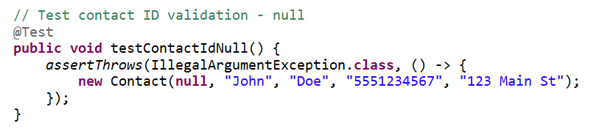
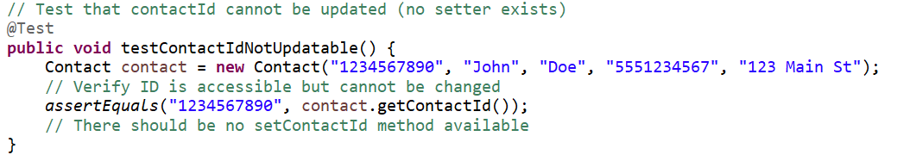
Code snippets testing the ID field for the Contact Service
(Similar tests were run for the Task and Appointment Services)
Similarly, for the listed requirement “The phone field must be exactly 10 digits” for the Contact service, I created multiple tests to ensure the code met the requirements: testPhoneExactly10Digits() to verify a valid 10-digit input, testPhoneTooShort() to verify rejection of a 9 digit input, testPhoneTooLong() to verify rejection of an 11 digit input, and testPhoneContainsNonDigits() to verify rejection of any input containing non-numeric characters. Although this block of tests was specific to the Contact service, as it was the only service that included a Phone field in the requirements, the other two services had similar fields that called for requirements bounded by specific values (e.g. the Task and Appointment services both had description fields that must be no longer than 50 characters and must not be null).
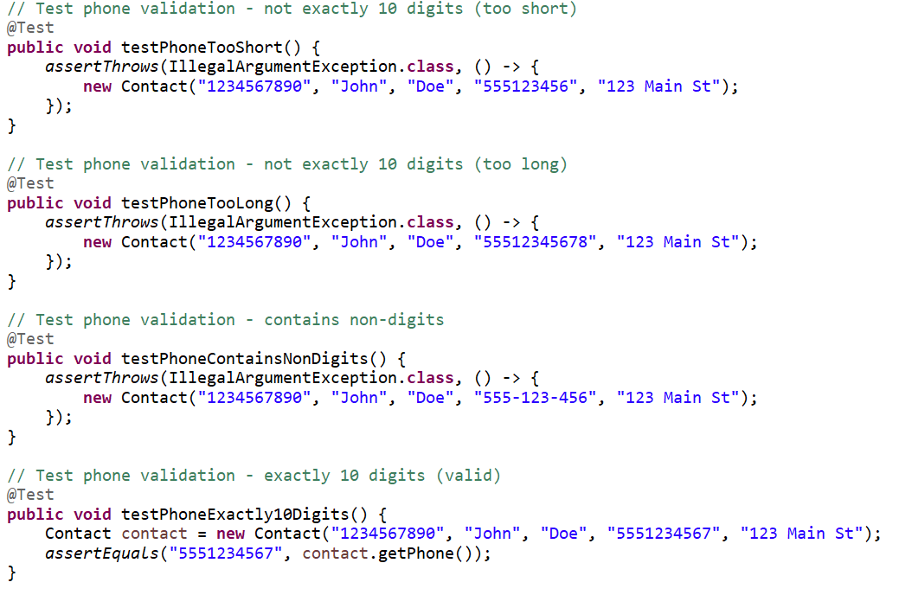
Code snippets of tests for Contact service, ensuring inputs fall within the specified boundaries set in the requirements.
  - Defend the overall quality of your JUnit tests. In other words, how do you know your JUnit tests were effective based on the coverage percentage?
This pattern of testing both valid inputs and various invalid inputs ensured comprehensive coverage of each requirement. I'm confident my JUnit tests were effective based on several factors: First, I achieved 100% method coverage - every public method in each class had at least one test. Second, I tested both positive scenarios (valid inputs) and negative scenarios (invalid inputs). For most features, I had more negative tests than positive tests because there are many ways to provide invalid input but usually only one correct way. For example, for the Contact constructor, I had 1 positive test (testContactCreation() with all valid inputs), but more than 15 negative tests (null values, too-long strings, invalid phone format, etc.). Third, I used boundary value testing extensively. Every length constraint had three tests: just under the limit (valid), exactly at the limit (valid), and just over the limit (invalid). This approach catches off-by-one errors, which are common in validation logic. Finally, all 173 tests passed, which means the production code correctly implements all requirements. If a requirement wasn't met, at least one test would have failed.
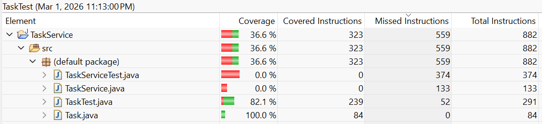
The TaskTest set of unit tests achieved 100% coverage for the Task class, assuring that all elements were tested against.
- Describe your experience writing the JUnit tests.
  - How did you ensure that your code was technically sound?
To ensure that my tests were technically sound, I made sure to utilize the proper JUnit syntax so that all tests would run properly and as expected. This included using the @BeforeEach prefix to ensure proper test isolation so that each test started with a fresh instance of whatever service was being tested, to prevent interference between tests.
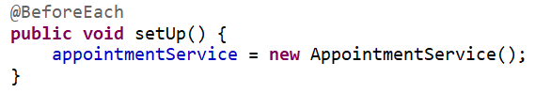
  - How did you ensure that your code was efficient?
To help ensure efficiency in my testing, I created reusable helper methods to avoid duplication, such as the getFutureDate() helper method used in the AppointmentServiceTest class. Without this helper method, I would have repeated these three lines in 20+ tests.
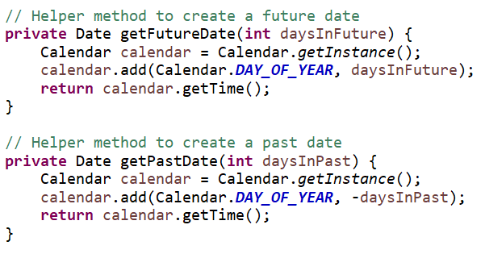
Helper methods used in the AppointmentServiceTest.
Reflection
- Testing Techniques
  - What were the software testing techniques that you employed in this project? For each of the techniques you discussed, explain the practical uses and implications for different software development projects and situations.
Unit Testing was the primary technique I used for the project. I tested each class and method independently using JUnit 5. The tests were run in isolation without external dependencies, each test focusing on a single unit of functionality. Tests were automated and could be run repeatedly with fast execution. Unit Testing is essential for any software project, but is particularly valuable in agile development where code changes frequently. The automated tests act as a safety net - if you change something and break existing functionality, a test will fail immediately. This is much faster than manually testing everything after each change.
Boundary Value Testing is critical for any system with input validation - which is almost everything, this project included. I tested values at the exact limits of acceptable ranges. For example, with the 10-character contact ID limit, I tested 10 characters (should pass), as well as 11 characters (should fail) as inputs. This is important because bugs often occur at boundaries. I also used Positive / Negative testing to ensure both that valid inputs were accepted (positive) and invalid inputs threw an exception (negative). About 60% of my tests were negative tests because there are many ways to provide bad input. Through testing negative inputs, I also utilized Exception testing, as every validation rule that should throw an exception had a test using assertThrows(). This verified that the code failed safely rather than accepting invalid data or crashing.
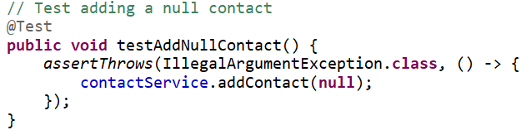
assertThrows() was used to ensure bad input would throw an exception.
  - What are the other software testing techniques that you did not use for this project?
There were a variety of testing techniques that I did not utilize in the project, mostly because they were unnecessary for the project, or simply out of scope of the material. Included in these techniques are Integration Testing (which was unnecessary, as each of the three services were run in isolation from each other), Performance Testing (which was unnecessary because the datasets being used were negligibly small and the program used in-memory storage to run), and Security Testing (which, though certainly important in a robust testing environment, fell outside of the scope of this course’s requirements and material).
- Mindset
  - Assess the mindset that you adopted working on this project. In acting as a software tester, to what extent did you employ caution? Why was it important to appreciate the complexity and interrelationships of the code you were testing?
As a tester, I adopted a cautious, skeptical mindset. I assumed that things could go wrong and therefore tried to break the code, which differs greatly from the traditional developer mindset of "make it work." For example, when testing the phone number validation, I didn't just test one valid phone number but also tested a variety of different kinds of invalid inputs to ensure that each one would be properly caught by the program by throwing an exception. This caution is important because users will inevitably try unexpected inputs. The code needs to handle these gracefully rather than crashing or accepting invalid data.
  - Assess the ways you tried to limit bias in your review of the code. On the software developer side, can you imagine that bias would be a concern if you were responsible for testing your own code?
Testing your own code is challenging because of inherent bias. As the developer, I knew how the code was supposed to work, which could blind me to unexpected use cases. I tried to limit bias by writing tests before looking at implementation details, focusing on the listed requirements, rather than how I thought (and eventually knew) the code worked. I also tried to test from a user’s perspective, trying to imagine what a real person would input into a phone number field. This could potentially include dashes, spaces, or parentheses to account for formatting.
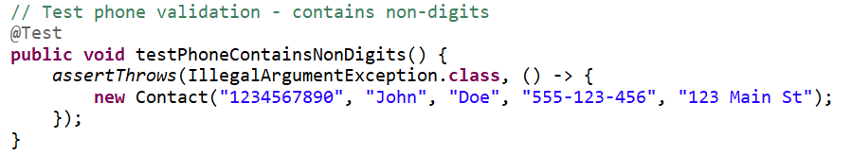
Unit test accounting for non-digit inputs for the Phone number field.
Compared to a more robust and complex program, however, it was fairly easy to limit bias in the coding because, as mentioned above, the requirements were clear cut, which allowed for precise testing to ensure all expectations were objectively met. Bias could be much more problematic in a real development scenario. If I spent hours debugging a complex piece of code, I might unconsciously avoid testing the parts that were difficult to write, or I might test only the scenarios I already know work.
  - Finally, evaluate the importance of being disciplined in your commitment to quality as a software engineering professional. Why is it important not to cut corners when it comes to writing or testing code? How do you plan to avoid technical debt as a practitioner in the field?
Being disciplined about quality is crucial for several reasons. First, cutting corners in testing creates technical debt. If I skip writing tests for "simple" methods, those untested methods become risky to change later. Future developers won't know if their changes break something. Second, poor quality has real costs. In a professional setting, bugs that reach production are expensive, only growing more costly the further into the development process the bug goes unsolved. Finally, quality is easier to build in than to add later. Writing tests alongside the code is much faster than trying to add tests to existing code. To avoid technical debt as a practitioner, it is good practice to write tests for every single feature, even seemingly simple ones. Additionally, all tests should be readable, efficient, and maintainable, so that anyone else working with you on testing is able to quickly understand your thought process and build onto it. Most importantly, all tests should be run before code is approved to be committed. If any of the tests fail, don’t commit the code. Moving forward, I plan to carry these practices into future projects, understanding that quality assurance is not a separate phase but an integral part of the development process.

